**Name : Gowtham S**

**Batch : 1**

**Assessment Date : 20-03-2023**

create table Bus(RouteNo int primary key,

Source varchar(20), Destination varchar(20));

create table Passenger(PID int primary key,

Pname nvarchar(20),

YOB nvarchar(20),

Gender nvarchar(20));

create table Book_Ticket(PID int foreign key references Passenger,

Routeno int foreign key references Bus,

Journey_Date date,

Seat_No int Primary key);

select * from Bus;

select * from Passenger;

select * from Book_Ticket;

insert into Bus values(1001, 'Mumbai', 'Chennai');

insert into Bus values(99, 'Coimbatore', 'Chennai');

insert into Bus values(1002, 'Banglore', 'Chennai');

insert into Bus values(98, 'Coimbatore', 'Madurai');

insert into Bus values(6, 'Chennai', 'Kanyakumari');

insert into Passenger values(1777, 'Rajesh', '1974-06-12', 'Male');

insert into Passenger values(1778, 'Rajinesh','1974-06-12', 'Male');

insert into Passenger values(1779, 'Priya', '1974-08-06', 'Female');

insert into Passenger values(1780, 'Hema', '1974-05-18', 'Female');

insert into Passenger values(1781, 'Gowtham', '2001-06-17', 'Male');

insert into Passenger values(1782, 'Rocky', '1987-09-15', 'Male');

insert into Book_Ticket values(1777, 99, '2022-06-07', 12);

insert into Book_Ticket values(1778, 99, '2022-06-07', 13);

insert into Book_Ticket values(1779, 99, '2022-06-07', 14);

insert into Book_Ticket values(1780, 99, '2022-06-07', 15);

insert into Book_Ticket values(1781, 1001, '2022-06-07', 16);

insert into Book_Ticket values(1782, 1001, '2022-06-07', 17);

**a)**

**select Source, Destination from Bus where Routeno = 99;**

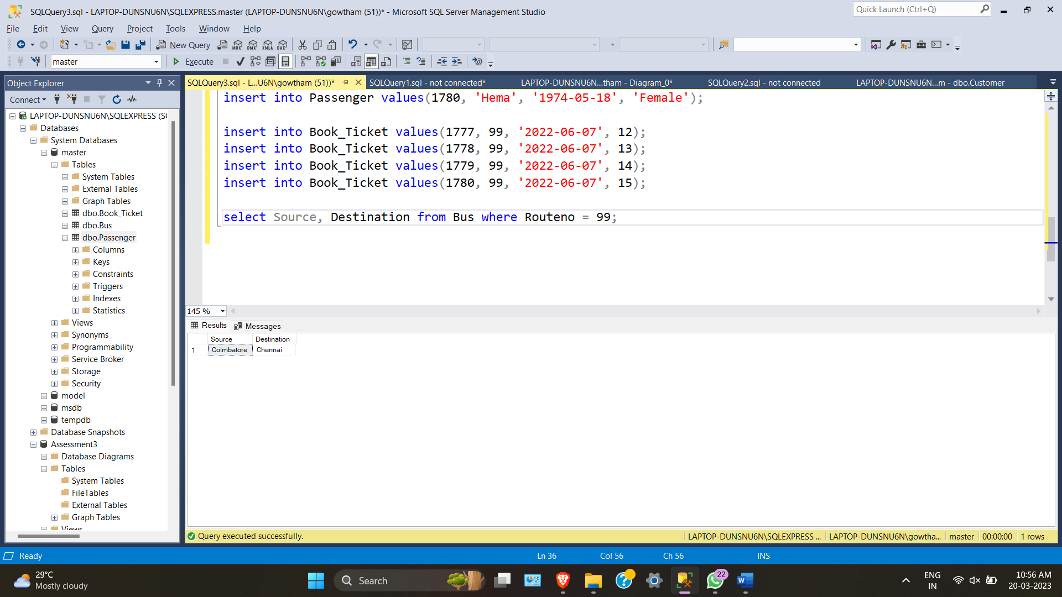

**b)**

**select t.PID**

**from Book_Ticket t**

**INNER JOIN Bus b**

**ON t.RouteNo = b.Routeno**

**where Source='Mumbai'and Destination='Chennai';**

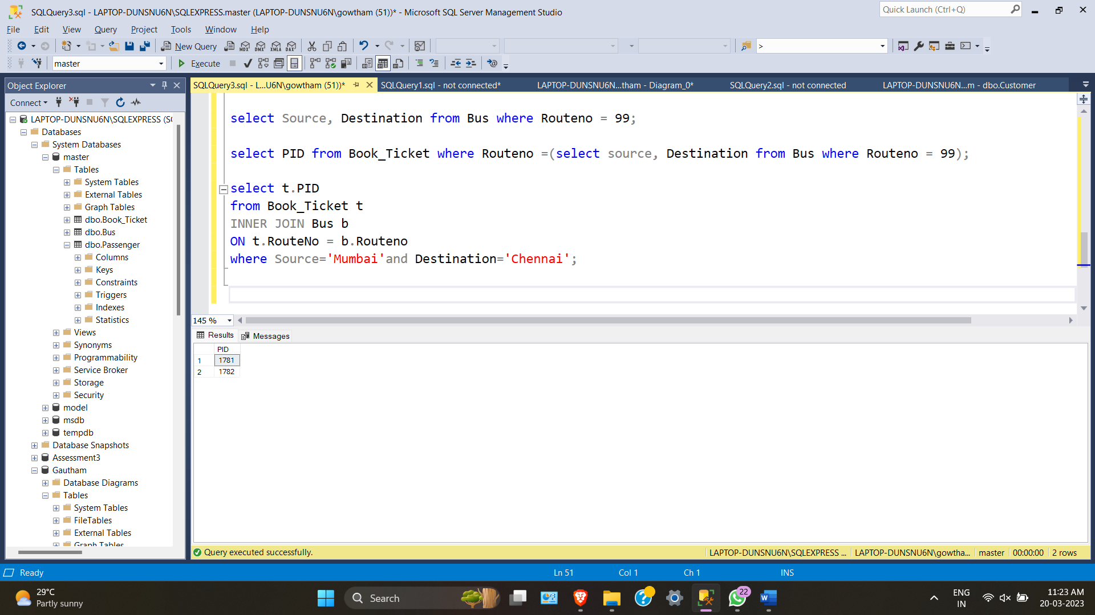

**c) select Gender, COUNT(Gender) AS PCount from Passenger**

**group by Gender**

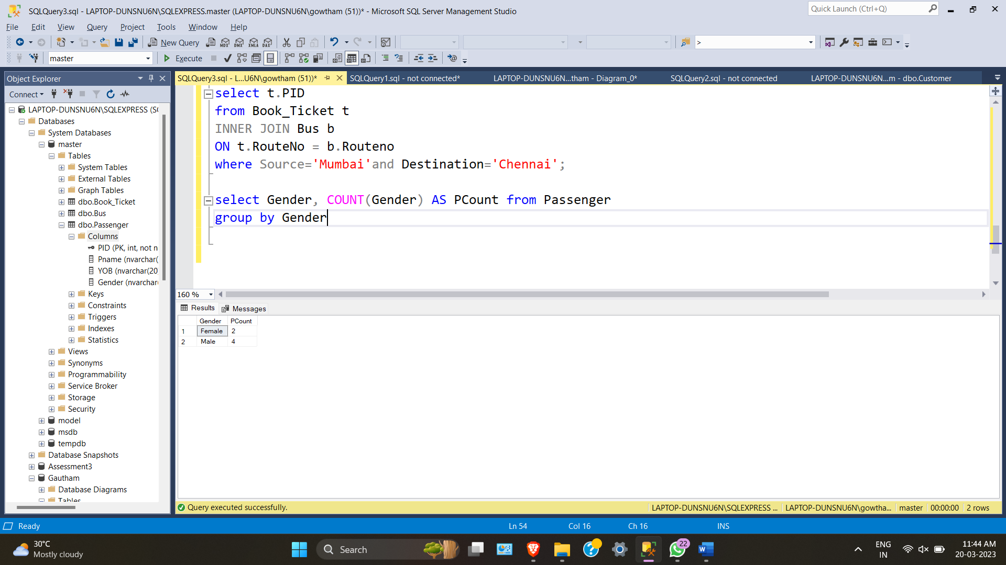

**d) select b.RouteNo, b.Source, b.Destination**

**from Bus b**

**INNER JOIN Book_Ticket t**

**ON t.RouteNo = b.Routeno**

**where t.Journey_Date = '2022-06-07';**

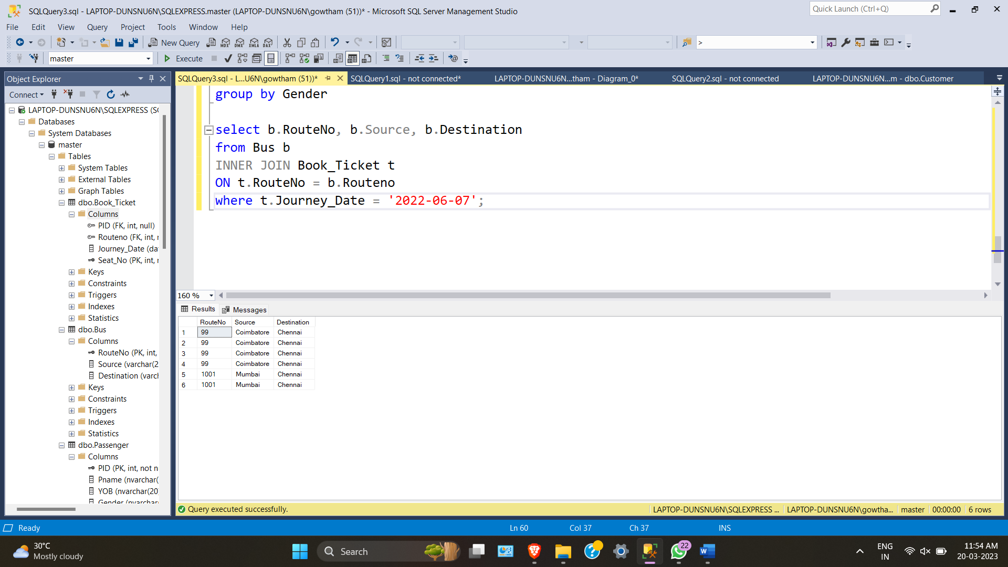

**e)CREATING PROCEDURE**

**CREATE PROCEDURE Detail**

**-- Add the parameters for the stored procedure here**

**AS**

**BEGIN**

**-- SET NOCOUNT ON added to prevent extra result sets from**

**-- interfering with SELECT statements.**

**SET NOCOUNT ON;**

**-- Insert statements for procedure here**

**SELECT * from Passenger**

**where YOB = '1974-05-18';**

**END**

**GO**

**exec detail;**

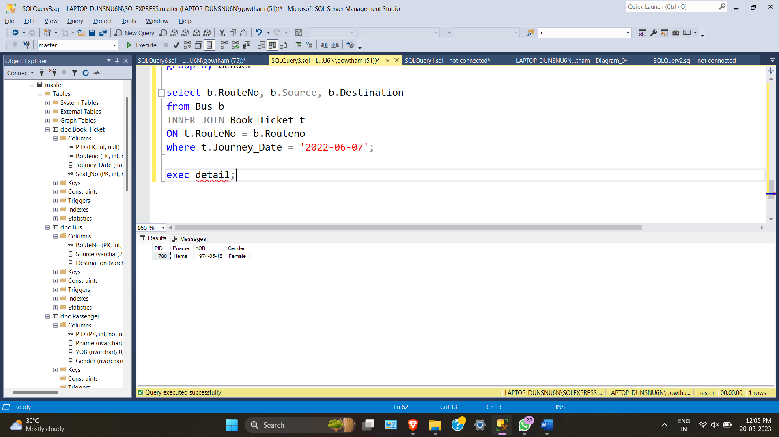

**f) CREATE FUNCTION udf_passenger**

**(**

**)**

**RETURNS TABLE**

**AS**

**RETURN**

**(**

**select source from bus where routeno=6**

**)**

**GO**

**select * from udf_passenger();**

